Name: Shams nasr eldeen ahmed

B.N: 390

Group: 3

Topic: Artificial intelligence

Dr: ahmed bayoumi

Dr: shady elmashad

Dr:Abdelhamid attaby

Git-hub link :

Screen shots : -

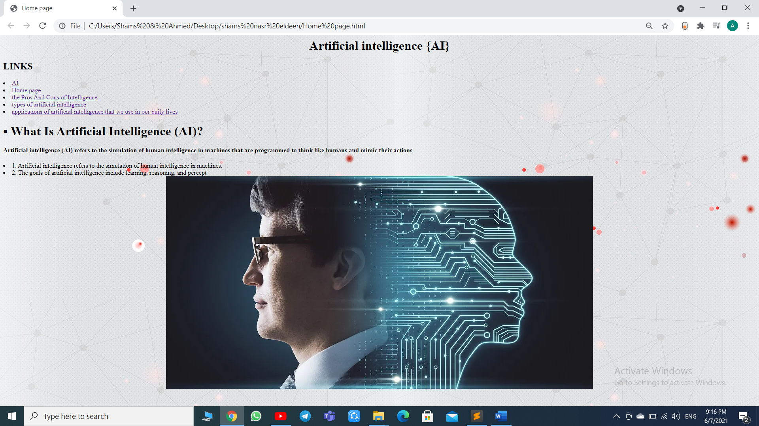

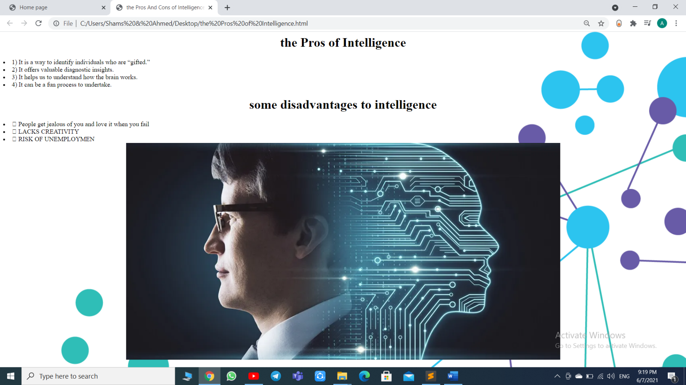

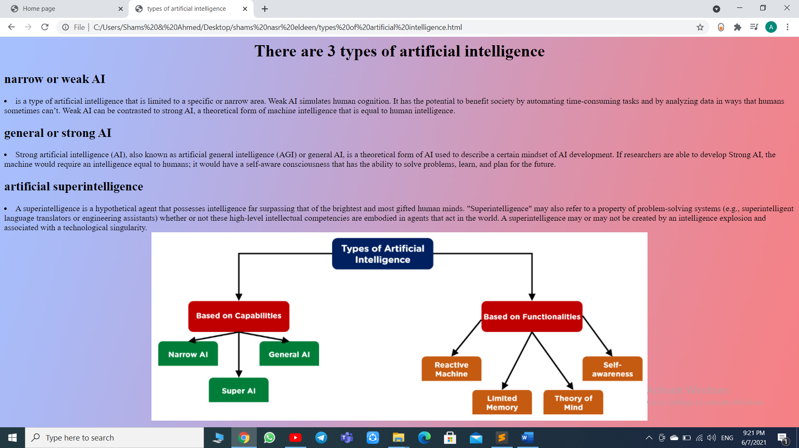

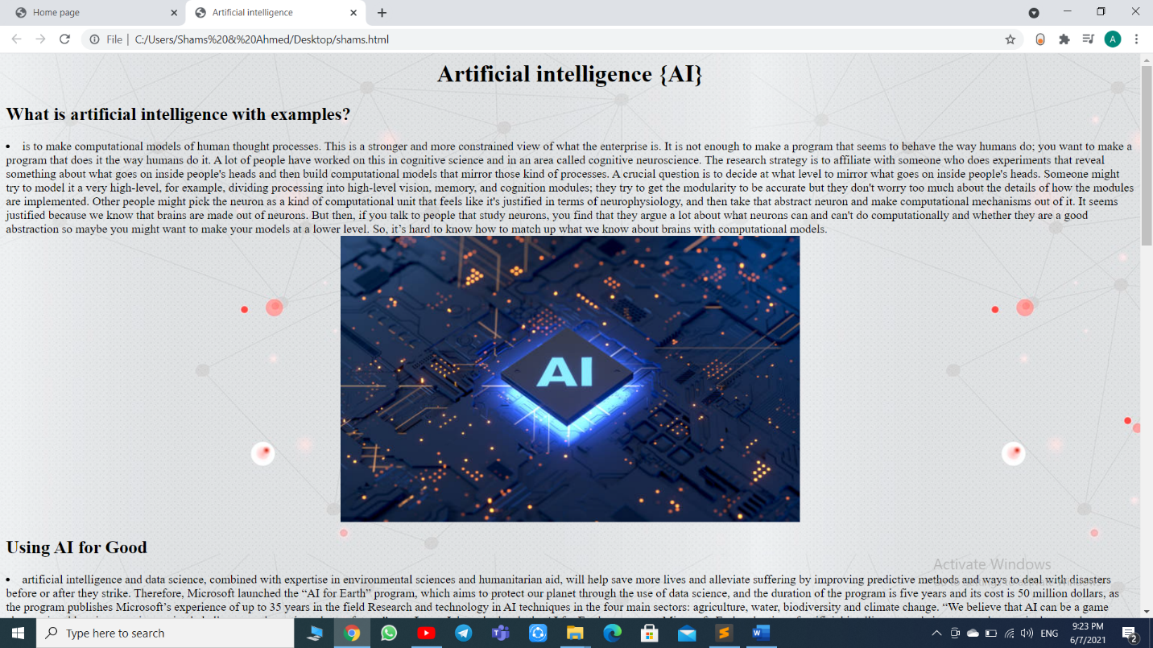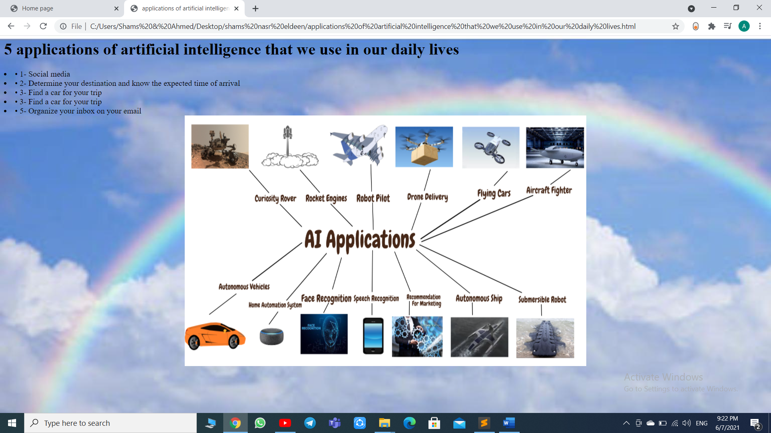

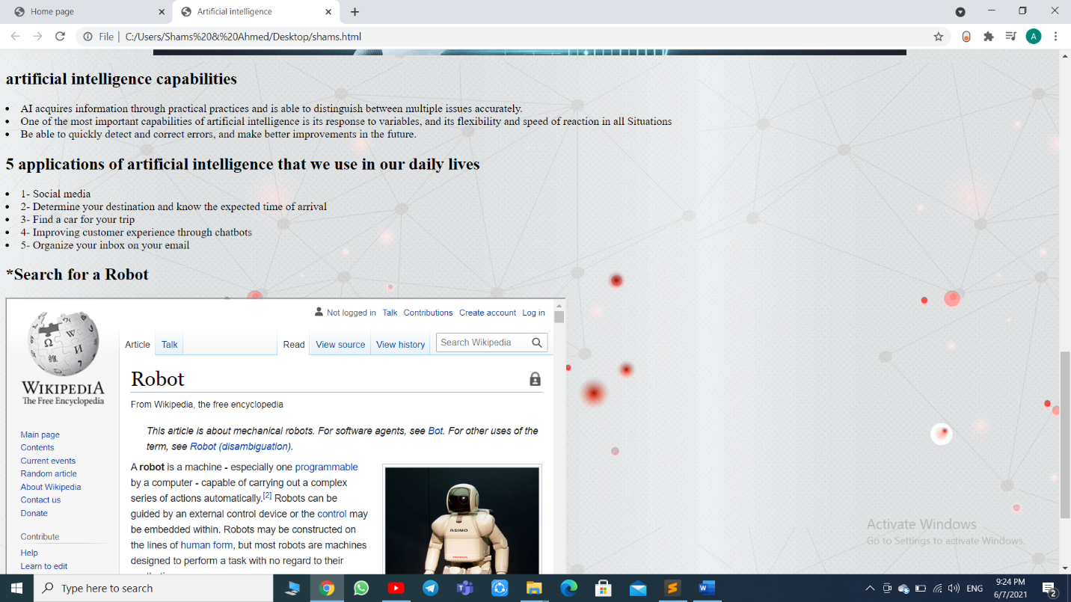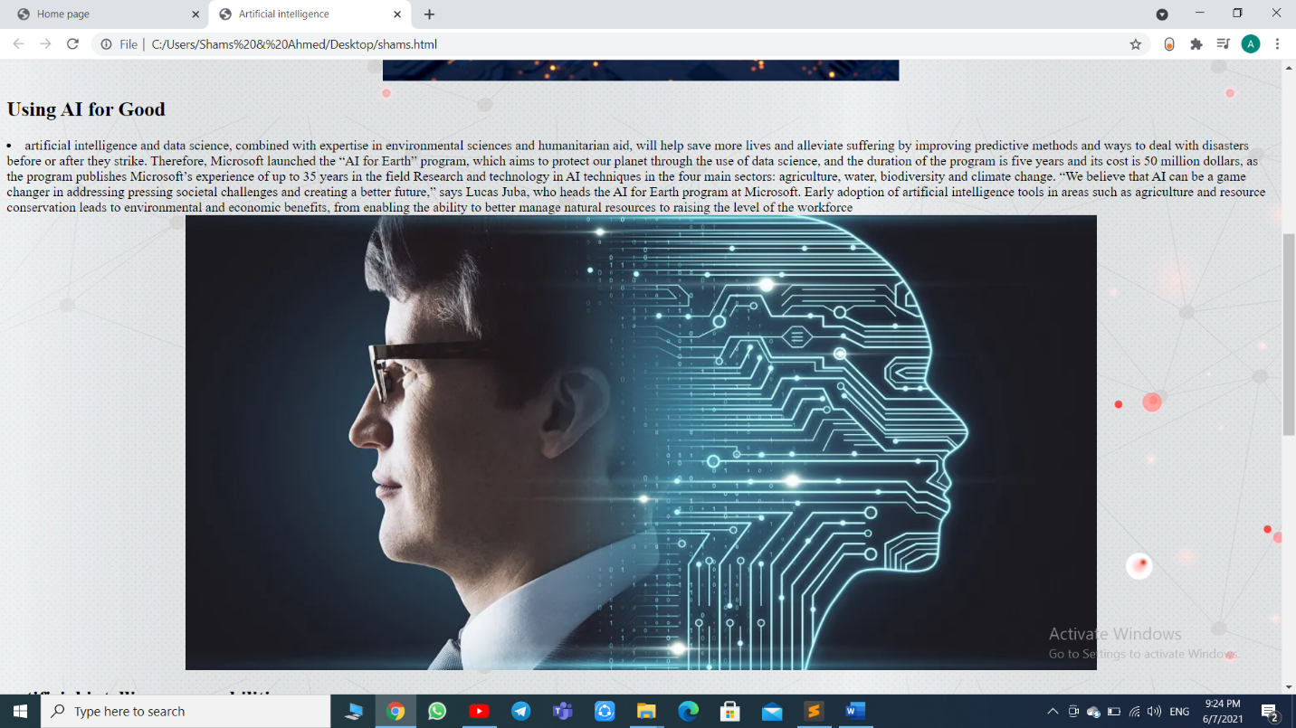

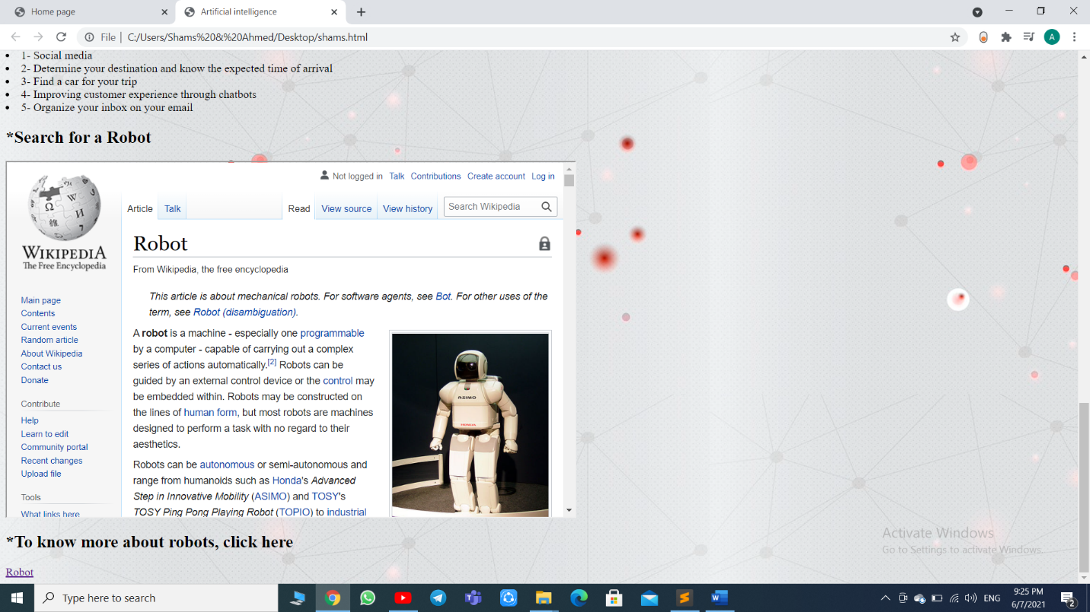HTML code screen shots



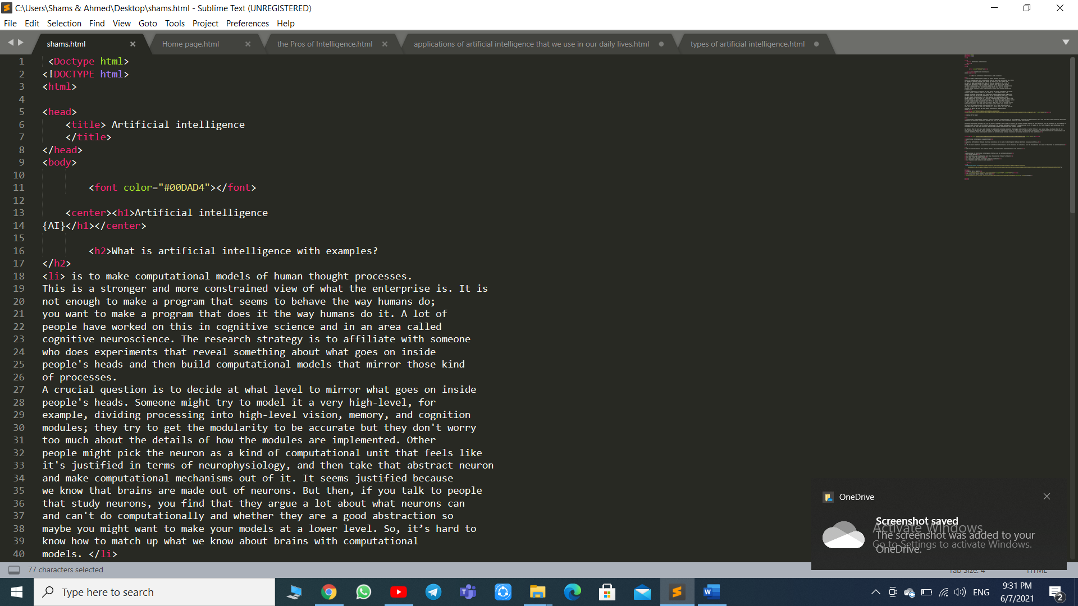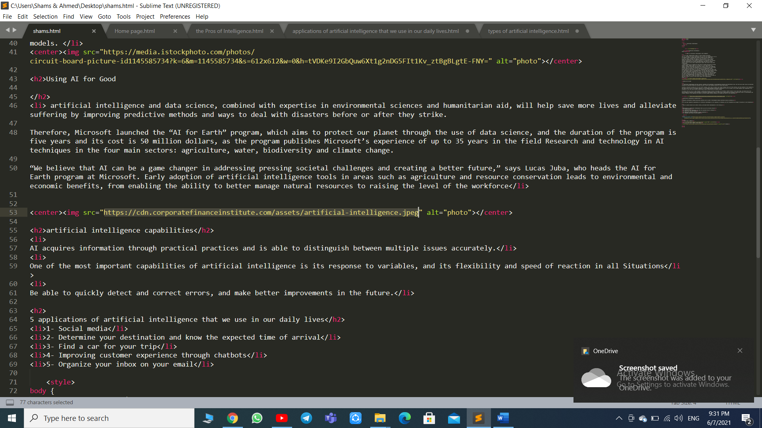

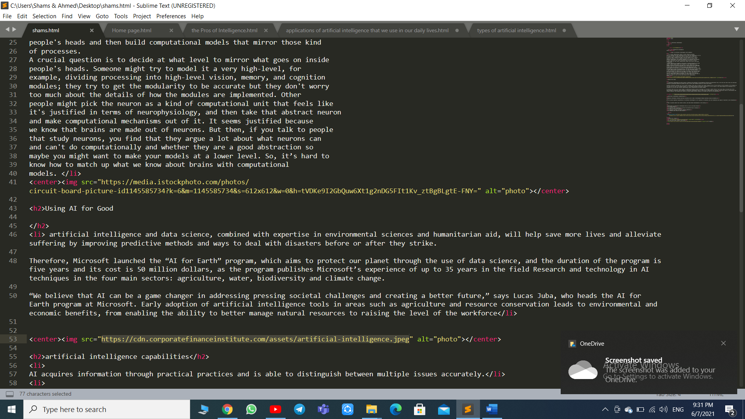



# Artificial Intelligence

## **What Is Artificial Intelligence (AI)?**

Artificial intelligence (AI) refers to the simulation of human intelligence in machines that are programmed to think like humans and mimic their actions

1. Artificial intelligence refers to the simulation of human intelligence in machines.
2. The goals of artificial intelligence include learning, reasoning, and percept

**the Pros of Intelligence**

1. It is a way to identify individuals who are “gifted.”
2. It offers valuable diagnostic insights.
3. It helps us to understand how the brain works.
4. It can be a fun process to  undertake.

 some disadvantages to intelligence

### People get jealous of you and love it when you fail

* LACKS CREATIVITY.
* RISK OF UNEMPLOYMEN

There are **3 types of artificial intelligence**

* narrow or weak AI

is a type of [artificial intelligence](https://www.investopedia.com/terms/a/artificial-intelligence-ai.asp) that is limited to a specific or narrow area. Weak AI simulates human cognition. It has the potential to benefit society by automating time-consuming tasks and by analyzing data in ways that humans sometimes can’t. Weak AI can be contrasted to [strong AI](https://www.investopedia.com/terms/s/strong-ai.asp), a theoretical form of machine intelligence that is equal to human intelligence.

* general or strong AI

Strong artificial intelligence (AI), also known as artificial general

intelligence (AGI) or general AI, is a theoretical form of AI used to describe a certain mindset of AI development. If researchers are able to develop Strong AI, the machine would require an intelligence equal to humans; it would have a self-aware consciousness that has the ability to solve problems, learn, and plan for the future.

* **artificial** superintelligence

A **superintelligence** is a hypothetical [agent](https://en.wikipedia.org/wiki/Intelligent_agent) that possesses [intelligence](https://en.wikipedia.org/wiki/Intelligence) far surpassing that of the [brightest](https://en.wikipedia.org/wiki/Genius) and most [gifted](https://en.wikipedia.org/wiki/Intellectual_giftedness) human minds. "Superintelligence" may also refer to a property of problem-solving systems (e.g., superintelligent language translators or engineering assistants) whether or not these high-level intellectual competencies are embodied in agents that act in the world. A superintelligence may or may not be created by an [intelligence explosion](https://en.wikipedia.org/wiki/Technological_singularity#Intelligence_explosion) and associated with a [technological singularity](https://en.wikipedia.org/wiki/Technological_singularity).

## 5 applications of artificial intelligence that we use in our daily lives

• 1- Social media

• 2- Determine your destination and know the expected time of arrival

• 3- Find a car for your trip

• 4- Improving customer experience through chatbots

• 5- Organize your inbox on your email

# **Robot**

A **robot** is a machine - especially one [programmable](https://en.wikipedia.org/wiki/Computer_program) by a computer - capable of carrying out a complex series of actions automatically.[[2]](https://en.wikipedia.org/wiki/Robot#cite_note-2) Robots can be guided by an external control device or the [control](https://en.wikipedia.org/wiki/Robot_control) may be embedded within. Robots may be constructed on the lines of [human form](https://en.wikipedia.org/wiki/Humanoid_robot), but most robots are machines designed to perform a task with no regard to their aesthetics.

Robots can be [autonomous](https://en.wikipedia.org/wiki/Autonomous_robot) or semi-autonomous and range from humanoids such as [Honda](https://en.wikipedia.org/wiki/Honda)'s *Advanced Step in Innovative Mobility* ([ASIMO](https://en.wikipedia.org/wiki/ASIMO)) and [TOSY](https://en.wikipedia.org/wiki/TOSY)'s *TOSY Ping Pong Playing Robot* ([TOPIO](https://en.wikipedia.org/wiki/TOPIO)) to [industrial robots](https://en.wikipedia.org/wiki/Industrial_robot), [medical operating robots](https://en.wikipedia.org/wiki/Robot-assisted_surgery), patient assist robots, dog therapy robots, collectively programmed [*swarm* robots](https://en.wikipedia.org/wiki/Swarm_robotics), [UAV drones](https://en.wikipedia.org/wiki/UAV_drones) such as [General Atomics MQ-1 Predator](https://en.wikipedia.org/wiki/General_Atomics_MQ-1_Predator), and even microscopic [nano robots](https://en.wikipedia.org/wiki/Nanorobotics). By mimicking a lifelike appearance or automating movements, a robot may convey a sense of intelligence or [thought](https://en.wikipedia.org/wiki/Agency_(philosophy)) of its own. [Autonomous things](https://en.wikipedia.org/wiki/Autonomous_things) are expected to proliferate in the coming decade,[[3]](https://en.wikipedia.org/wiki/Robot#cite_note-3) with home robotics and the [autonomous car](https://en.wikipedia.org/wiki/Autonomous_car) as some of the main drivers.[[4]](https://en.wikipedia.org/wiki/Robot#cite_note-4)